**Deadheads Limitation**

***Work-flow to Use Deadheads Limitation***

Use **Load Template** to set up the preference for several conditions



Repeat **Load Template** for additional instances of any template



***Preference Overview***

This a set of complimentary preference instances that set distance limits for depot pull out and depot pull in trips. The purpose is to keep vehicles as close a s possible to their "home" depots.

The templates refer to **Depot distance limit** or **Deadhead distance limit** rather than specifically to Pull out and Pull in. The effect of the preference is all follos:

**For Pull outs:**

The preference limits the Pull out distance a vehicle may travel to perform a service trip. It serves to keep vehicles in the general vicinity of their "home" depots.

**For Pull ins:**

At the end of a work day, the vehicle will return to its "home" depot if the distance to travel it is less than a specified maximum. Otherwise, the vehicle will be parked in nearest depot.

***Templates Available from Optibus***

*Table 1-1: Templates Summary*

|  |  |  |
| --- | --- | --- |
| **Template Name** | **Purpose** | **Reference** |
| Reduce depot checks | Sets a maximum distance limit for return to depot trips. | **Reduce depot checks** |
| Minimize Vehicle  Cruise Restriction | Set as a constraint, the maximum distance for an exit depot deadhead. | **Minimize Vehicle**  **Cruise Restriction** |
| Minimize Vehicle  Cruise Preference | Set the maximum distance for an exit depot deadhead with a penalty. | **Minimize Vehicle**  **Cruise Preference** |

Sets a maximum distance limit for return to depot trips.

**Prerequisites:** None.

**Opening Dialog:**

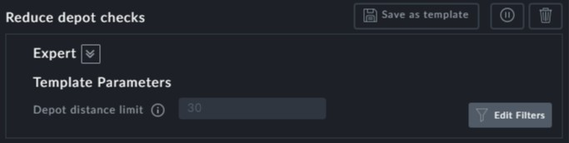

**Points to note:**

**Depot distance limit**: This field is a constraint, since under normal conditions, the driver has no discretion in the matter



If you set it to zero, vehicles will always return to their "home" depot



The unit of distance (Km, miles) depends on your location



Set as a constraint, the maximum distance for an exit depot deadhead.

**Prerequisites:** None.

**Opening Dialog:**

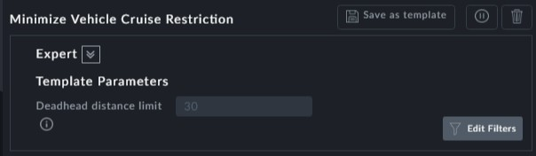

**Points to note:**

**Deadhead distance limit**: This field is a constraint



The unit of distance (Km, miles) depends on your location



Set the maximum distance for an exit depot deadhead with a penalty.

**Prerequisites:** None.

**Opening Dialog:**

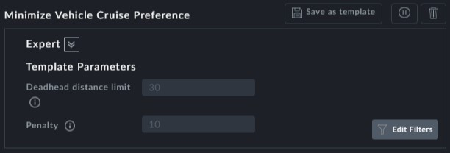

**Points to note:**

This preference is a flexible version of **Minimize Vehicle Cruise Restriction**



**Deadhead distance limit**: This field is flexible.



The unit of distance (Km, miles) depends on your location

